**Sorori Shinzaemon problem**

**【Problem 1] Number of grains of rice on the 100th day**

# Initialize variables

days = 100

daily_rice = 1

total_rice = 0

daily_rice_list = []

cumulative_rice_list = []

# Calculate rice grains for 100 days

for day in range(1, days + 1):

    daily_rice_list.append(daily_rice)

    total_rice += daily_rice

    cumulative_rice_list.append(total_rice)

    daily_rice *= 2

print("Rice grains on Day 100: {:,}".format(daily_rice_list[-1]))

print("Total rice grains after 100 days: {:,}".format(total_rice))

**OUTPUT**

Rice grains on Day 100: 633,825,300,114,114,700,748,351,602,688

Total rice grains after 100 days: 1,267,650,600,228,229,401,496,703,205,375

# Plot the transition

plt.figure(figsize=(12, 6))

# Daily rice grains received

plt.subplot(1, 2, 1)

plt.plot(range(1, days + 1), daily_rice_list, color='blue', label='Daily Rice Grains')

plt.title("Daily Rice Grains", fontsize=14)

plt.xlabel("Day", fontsize=12)

plt.ylabel("Rice Grains", fontsize=12)

plt.yscale('log')

plt.legend()

plt.grid(True)

# Cumulative rice grains

plt.subplot(1, 2, 2)

plt.plot(range(1, days + 1), cumulative_rice_list, color='green', label='Cumulative Rice Grains')

plt.title("Cumulative Rice Grains", fontsize=14)

plt.xlabel("Day", fontsize=12)

plt.ylabel("Rice Grains", fontsize=12)

plt.yscale('log')

plt.legend()

plt.grid(True)

plt.tight_layout()

plt.show()

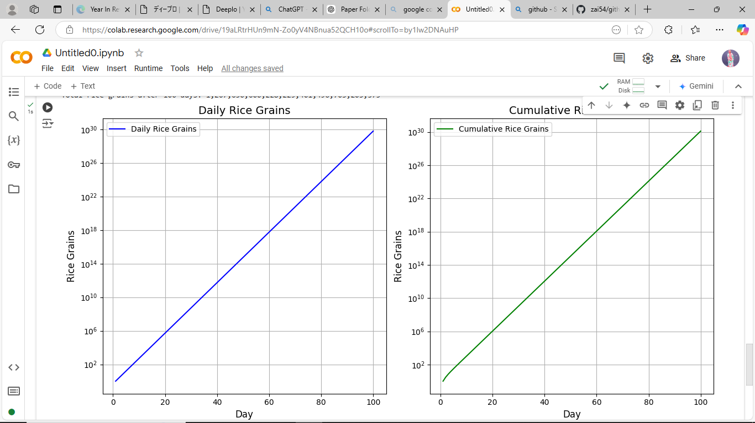

【**Problem 2] Number of rice grains outside of the 100th day**

import matplotlib.pyplot as plt

def compute_sorori_shinzaemon(n_days=100):

    daily_rice = 1

    total_rice = 0

    list_n_grains = []

    list_total_grains = []

    # Calculate rice grains for the given number of days

    for day in range(n_days):

        list_n_grains.append(daily_rice)

        total_rice += daily_rice

        list_total_grains.append(total_rice        daily_rice *= 2

    return list_n_grains, list_total_grains

n_days = 81

list_n_grains, list_total_grains = compute_sorori_shinzaemon(n_days=n_days)

print("Rice grains on Day {}: {:,}".format(n_days, list_n_grains[-1]))

print("Total rice grains after {} days: {:,}".format(n_days, list_total_grains[-1]))

**OUTPUT**

Rice grains on Day 81: 1,208,925,819,614,629,174,706,176

Total rice grains after 81 days: 2,417,851,639,229,258,349,412,351

# Plot the transition

plt.figure(figsize=(12, 6))

# Daily rice grains received

plt.subplot(1, 2, 1)

plt.plot(range(1, n_days + 1), list_n_grains, color='blue', label='Daily Rice Grains')

plt.title(f"Daily Rice Grains (Up to {n_days} Days)", fontsize=14)

plt.xlabel("Day", fontsize=12)

plt.ylabel("Rice Grains", fontsize=12)

plt.yscale('log')

plt.legend()

plt.grid(True)

# Cumulative rice grains

plt.subplot(1, 2, 2)

plt.plot(range(1, n_days + 1), list_total_grains, color='green', label='Cumulative Rice Grains')

plt.title(f"Cumulative Rice Grains (Up to {n_days} Days)", fontsize=14)

plt.xlabel("Day", fontsize=12)

plt.ylabel("Rice Grains", fontsize=12)

plt.yscale('log')

plt.legend()

plt.grid(True)

plt.tight_layout()

plt.show()

